Parish Council Meeting Minutes August 2nd, 2023
Attendees: Linda Gutoskey, Steve Bentz, Chris Stock, Don Clemmer, Katie Eckrich, Kathy Krouse, Joe McKenna, Steve Jahrsdoerfer, Mike O’Neil, Dennis Redding, Cynthia Crosby, Keith Heimann, Jared Hoy, Deacon Rob Lortie, Fr. Tom Fr. Bobby
1. Welcome of new members and review of parish council guidelines and objectives.
2. Parish directory photography has begun, so far so good.
3. School enrollment has increased year to year and classes begin August 9th.
4. Brother Jacob Eifrid will be taking his final vows as a Holy Cross brother at Notre Dame on August 26. We will try to schedule a subsequent weekend when he can attend Mass here and have a parish celebration.
5. An interfaith “field trip” has been scheduled on October 23rd at the Holy Trinity Greek Orthodox church on Wallen Road in Fort Wayne. Father Cosmin will provide a tour and explain some of their more prominent iconography visible in the sanctuary. Additional outreach is tentatively planned on November 21st at the Temple Achduth Vesholom on Old Mill Road in Fort Wayne. Both invitations are open to all interested parishioners.
6. Kingdom Builders has been meeting once per month in our parish, but have struggled to find a person to lead the chapter. Due to this, we are pausing future meetings until someone is able to step forward.
7. A group of three parishioners presented “Catholic Faith Topics” this year. They will present their talks again, condensed, on Saturday mornings in Lent.
8. Saint Charles parishioner Don Clemmer will be presenting a history of the modern papacy with a view of current cardinals on September 21st at 7:00 pm in the Hession Ctr.
9. Our nursery is looking for a volunteer to take the lead on organizing and scheduling individuals for the Sunday 9:00 and 11:00 masses.
10. We are currently in year number two, of a three-year initiative to bring greater focus on the Eucharist.
Saint Charles will be hosting the forty hours of devotion on February 25-27, 2024.
The National congress will take place in Indianapolis July 17-21, 2024.
11. The repairs to our parking lot have been completed, as have the new boiler instillation and stump removal around the campus.
12. We continue to plan for and quote new windows for the school and revamp the youth house for greater space utilization.
13. The Saint Vincent De Paul Society fundraiser “Walk For The Poor” will take place on October 1st. This is their biggest fundraiser of the year and provides many valuable dollars to those in need.
The next parish council meeting is September 6th at 7:00 pm
Reminder: Saint Charles Parish Council meetings are open to any parishioners who would like to attend. Feel free to show up and see how the sausage is made!

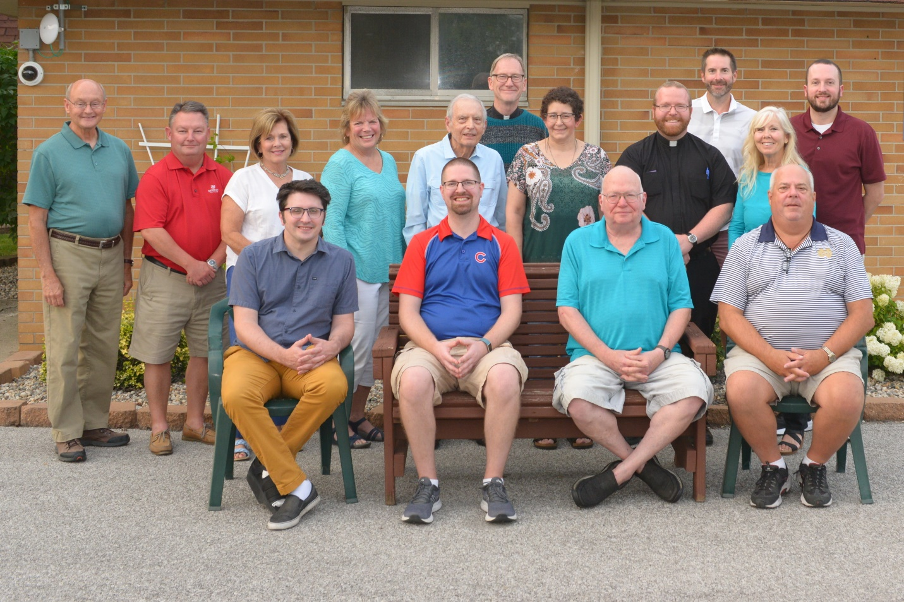

2023 – 2024 Parish Council Members

